WALTON PARISH COUNCIL

Clerk: Allison Riddell
Unit 2
The Old Brewery
Craw Hall
Brampton
CA8 1TR
Tel: 016977 3382 Email:clerk@waltonparish.co.uk

26th February 2020
Notice is hereby given that a meeting of WALTON PARISH COUNCIL will be held in THE VILLAGE HALL, WALTON, on TUESDAY 3rd MARCH 2020, at 7.30pm.

Members of the public are welcome to attend.

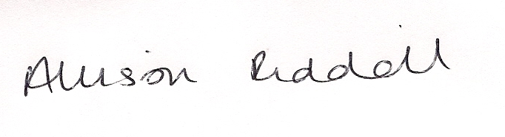

AGENDA

1. APOLOGIES FOR ABSENCE – To receive and accept apologies for absence.

2. REQUESTS FOR DISPENSATIONS - The clerk to report any requests received since the previous
meeting for dispensations to speak and\or vote on any matter where a member has a disclosable
pecuniary interest.

3. DECLARATIONS OF INTEREST – To receive declarations by elected and co-opted members of
interests in respect of items on this agenda.

4. MINUTEs
4.1 MinuteS of the meeting held on 7th JANUARY 2020 - To authorise the Chairman
to sign, as a correct record, the minutes of the meeting held on 7th November 2020.

5. PUBLIC PARTICIPATION - To receive comments and representations from members of the public
in relation to any item on the Agenda. (The Public Participation period will last 15 minutes and
members of the public are permitted to speak for up to 3 minutes. Members of the public are not
permitted to speak at any other time during the meeting unless invited to do so by the Chairman).

5.1 REPORTS – To receive reports, if applicable, from City and County Councillors.

6. REPRESENTATIVES' REPORTS - To receive information and reports by representatives on Outside
Bodies.

7. Town and country planning APPLICATIONS – To be considered –

None to date.

8. NOTIFICATION OF DECISIONS – To note a report from the Clerk.

9. FINANCIAL MATTERS -

9.1 BANK RECONCILIATION TO 31.01.20 – To note a report by the Clerk.

9.2 EXPENDITURE TO APPROVE – That the Council approve the expenditure detailed.
(copy herewith).

9.3 FINANCIAL ASSISTANCE – To consider any updates regarding requests for financial
assistance.

10. PARISH PLAN – To receive an update from Councillors Shaw and Brocklebank.

11. PLAY AREA – To receive an update on work required from the annual inspection.

12. DOG FOULING – To consider what action to take on dog fouling in the parish.

13. OLD CENTURION PUB – To consider what action to take on extending the listing of the Old
Centurion Pub as a community asset.

14. LOCAL PATHS AND TRACKS – To consider maintenance of local paths and tracks.

15. DRAINS IN WALTON – TO receive an update from Councillor Mounsey.

16. CALC – To receive, note and where applicable respond to the following correspondence, circulated
prior to the meeting by email:-

16.1 CALC CIRCULAR – February/March 2020.

16.2 NORTH WEST COASTAL ACCESS UPDATE

16.3 LOCAL ELECTRICITY BILL

17. CORRESPONDENCE RECEIVED BY THE CLERK - To note items of correspondence received
since the last meeting and take actions as appropriate. (circulated prior to the meeting by email)

17.1 CUMBRIA POLICE – North Cumbria News

17.2 WORKING TOGETHER SERVICE – Email from Cumbria County Council

17.3 BATTLE OF BRITAIN 80th CELEBRATIONS – Email from RAF Spadeadam

18. LITERATURE AVAILABLE FROM CLERK - To note items of literature received since the last
meeting:-

18.1 NOTICE OF EXECUTIVE KEY DECISIONS – 7th February 2020

19. AGENDA ITEMS FOR NEXT MEETING - To submit items for the next meeting and note that any
further items for consideration should be submitted to the Clerk on or before 28th April 2020.

20. DATE OF NEXT MEETING – Tuesday 5th May 2020, Village Hall, Walton, 7.30pm.

