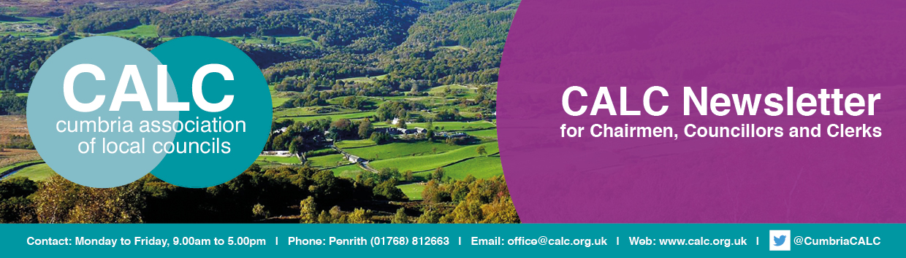

April 2019
This month ….
Annual Return Errors Costing Local Councils Money
The Chairman of the body procuring external auditors for local councils in England has expressed concern that more councils than previously are not responding to audit return requests or are making other errors which are costing councils a substantial amount of money. Michael Attenborough-Cox, Chairman of SAAA Ltd, has said that, in respect of the Annual Governance and Audit Return (AGAR) for 2017/18, there were a substantial number of non-responders and statutory deadlines were missed resulting in a significant number of statutory recommendations and public interest reports being issued; far greater than in previous years. The cost to local councils has also been significant as a result of non- compliance.
To ensure greater compliance for the 2018/19 AGAR, please comply with the following advice of SAAA Ltd:
- Clerks/RFO’s should read the instructions and guidance provided by their auditors and in the AGAR before attempting to complete the appropriate form.
- Completed forms MUST be returned to the auditor by the statutory deadline, 30 June, either by email or post NOT BOTH. Failure to comply will result in authorities being faced with additional costs.
- If an authority fails to respond to the auditor’s reminder letters, the auditor is likely to issue a Public Interest Report, the minimum cost being £200 plus VAT and the authority will be required to have a limited assurance review the following year with a minimum cost of £200 plus VAT
- Authorities must inform their auditor of a change of contact details of the Clerk/RFO and Chairman.
- Authorities should be able to be contacted through generic email addresses.

Intermediate External Audits
All councils in England should by now have received an 'instruction' email from their external auditor. Those councils selected for the '5% sample' for 'intermediate' audit will receive a separate email from the external auditor. Please make sure the external auditor has your correct email contact details - see the contact details below.
As with last year, councils which are eligible to certify as exempt from external audit, and do so, are not required to submit information to the external auditor (other than a certificate of exemption) even if they are within the 5% sample.
Contact for Cumbria’s External Auditor
PKF Littlejohn LLP
SBA Team,
1 Westferry Circus,
Canary Wharf,
London E14 4HD
email: sba@pkf-littlejohn.com
Tel: 020 7516 2200



The Lake District National Park’s Local Plan
The Lake District National Park Authority (LDNPA) has published its Pre-Submission Local Plan for further consultation prior to submitting it to the Secretary of State for Communities and Local Government for examination.
The Pre-Submission Local Plan sets out the broad spatial planning, policy framework and vision for the Lake District up to 2035, as well as the necessary development sites to support this growth. It will be used to make decisions on future planning applications.
The consultation documents comprise of:
· Pre-Submission Local Plan
· Proposed site allocations
Representations at this stage should only be made on the legal and procedural compliance of the Pre-Submission Local Plan, the soundness of the Local Plan and whether the Authority is in conformity with the Duty to Cooperate.
Comments are invited on the consultation documents during the eight week consultation period commencing on Monday 8 April 2019 and concluding on Monday 03 June 2019. A dedicated Local Plan webpage has been set up. Please visit http://www.lakedistrict.gov.uk/localplan to view the documents and/or give us your comments using the electronic survey form.
For further information please email localplan@lakedistrict.gov.uk

Major Review of Planning Calls for Sweeping Reforms
The Raynsford Review of Planning, led by former Housing Minister, Nick Raynsford has released its final report, Planning 2020.
This hard-hitting report concludes that, ‘the current planning system in England does not work effectively in the long term public interest of the nation,’ adding that ‘planning has been reduced to a chaotic patchwork of responsibilities which is not compatible with promoting the health, wellbeing and civil rights of communities’.
The report makes it clear that while planning has huge potential to make people’s lives better, this opportunity is being undermined by deregulation. It calls for major reforms in the planning systems, many of which will strike a chord with parish and town councillors across Cumbria.
Further details about the review and its findings can be found at
https://www.tcpa.org.uk/raynsford-review.

Parish Council Share of Council Tax to Increase by a Penny a Day in 2019/20
Figures released at the end of March by the Ministry for Housing, Communities and Local Government (MHCLG) show the average increase in the small share of council tax raised by local (parish and town) councils will increase by a penny a day in 2019/2020.
The figures cover council tax and precept levels for a range of bodies in England including principal authorities such as county, district and unitary councils, and other bodies such as local councils.
Overall council tax requirement in 2019/20 will be £31.4 billion, with £554 million raised by local councils; this is an overall increase of £1.8 billion on last year, with the share levied by local councils increasing by £36 million.
The average Band D council tax set by local authorities will be £1,750 an increase of £78 per year, with the average Band D parish share going up by £3.65 per year, or 1p per day, from £64.04 to £67.69.
This small increase and additional investment in local communities reflects the growing role and importance of local councils as they support local communities, take on responsibilities previously provided by other levels of local government such as open spaces, street cleaning, libraries and youth services, and meet residents’ needs through other activities such as improving health and well being.

New Report Highlights the State of Rural Services in England
A report published last month highlights the state of rural services in England, showing basic mobile calls are not possible across main networks in a third of homes and residents are losing out as bus services are scrapped.
Rural England’s State of Rural Services 2018 report draws attention to the difficulties rural households face in accessing services such as broadband, public transport, libraries, healthcare, shops and young people's services. The State of Rural Services reports, the first published in 2016, are a response to concerns about gaps in the rural evidence base and aim to inform policy debate and help those making or delivering policies to take decisions which ultimately benefit rural communities.
This latest report highlights concerns that many of the National Association of Local Councils (NALC) 125,000 local councillors will share: that rural areas are being left behind and are increasingly dependent on voluntary activity at a local level.
Cllr Sue Baxter, chairman of NALC, said “The report identifies growing expectations that are being placed on communities and volunteers to sustain vital services within rural areas and, all too often, to stop them from disappearing. Local (parish and town) councils play an increasing role in the provision of libraries, youth clubs, transport schemes and supporting village shops and pubs. There is growing evidence this ultra-local model of community action can deliver service improvements and help maintain strong communities. However, some communities have fewer volunteers than others and there will be limits to volunteer capacity and capability.
Read the State of Rural Services 2018 report

Parish Clerk Vacancy
Eskdale Parish Council have a vacancy for a new Parish Clerk. Due to retirement we have a vacancy for a new Clerk to the Parish Council. The Council meets every other month on the second Tuesday but may meet in between these meetings to deal with Planning Applications. The salary is negotiable and is based on 100 hours per year. This is a professional position with full training available but it the post does require good IT and organisational skills. For an informal chat please contact the current Clerk, Dawn Pickles, or the Chairman, Mark Shaftesley on 019467 23357 or email eskdaleparishcouncil@gmail.com The closing date is Friday 12th April 2019.
CALC AGM, Wigton Market Hall, 10.30am Saturday 9th November 2019

The next meeting of the CALC Executive Committee will be on Saturday 15th June 2019 at 10.00am at Penrith Community Fire Station.


Landscape Grant Fund
Friends of the Lake District’s Landscape Grant Scheme funds small scale projects and works that conserve and enhance the landscape of Cumbria as well as events and activities that encourage people to get outside and enjoy its open spaces.
Applications will be considered for small scale projects and works that will conserve and enhance the landscape (and within that flora and fauna, cultural heritage), connect people with it and aid their enjoyment of it. Projects must demonstrate a clear and positive benefit to the landscape of Cumbria.
A Landscape Grant may also be awarded to activities or events which encourage access to the countryside or make a positive contribution to health and wellbeing. Activities can be for local people or visitors, but funders are particularly interested in those aimed at young people, older people, less abled people or others who may not normally go out and enjoy the landscape and wildlife that Cumbria has to offer.
Applications are welcome from charitable organisations, voluntary and community groups, schools, social enterprises and local councils or conservation agencies. Grant money is available but limited so funding is being offered on a rolling basis. Grant awards will normally be in the range of £100 -£2000 for landscape enhancements, and up to £500 for events.
Friends of the Lake District grants have helped to fund hundreds of projects which together, have made a major contribution to enhancing and safeguarding the landscape, environment and cultural heritage of Cumbria.
600 grants totalling more than £1 million have been awarded since the grant schemes inception in 1943 and you’ll find the details and location of them all on Friends of the Lake District’s Grant Awards Map at: https://www.friendsofthelakedistrict.org.uk/grants-mapping

Information and an application form are available on Friends of the Lake District’s website at https://www.friendsofthelakedistrict.org.uk/Pages/FAQs/Category/landscape-grants or by emailing Jan Darrall at jan-darrall@fld.org.uk

Samantha Bagshaw, Chief Officer, CALC

